|  |  |
| --- | --- |
| **ASSESMENT TEST** # **IV**  **MAX MARKS : 100 TIME: 180 Minutes** | **Test Objectives**   * *Basic understanding of JDBC* * *To understand Servlets* * *To understand the concept of JSP* |

**NAME: __________________ MARKS OBTAINED: ____ / 100 GRADE _____**

**I. Fill in the Blanks (40 *1 = 40)**

1. Before JDBC__________ was used to connect and execute query to the database
2. The _________________ uses ODBC driver to connect to the database.
3. The Native API driver uses the ____________ libraries of the database.
4. The ______________ method of Class class is used to register the driver class. This method is used to ______________ load the driver class.
5. The ______________ method of Connection interface is used to create statement
6. ______________ method of Statement interface is used to execute queries to the database
7. _________________ interface provides methods to execute queries with the database
8. The ___________ interface is a subinterface of Statement. It is used to execute ____________ query
9. The ____________ method of PreparedStatement is used to get Binary information and the ___________method of PreparedStatement is used to get file information from the database.
10. To call the stored procedures and functions_____________ interface is used
11. In JDBC, _____________ nterface provides methods to manage transaction.
12. The ___________ and ___________ interfaces provides methods for batch processing.
13. Servlet technology is used to create ____________application
14. HTTP stands for _________________________
15. HTTP is a _______________ protocol.
16. ________________ server contains only web or servlet container.
17. The _______________ contains interfaces and classes that are responsible for http requests only.
18. ______________ interface provides common behaviour to all the servlets.
19. _______________ method of servlet and invoked by the web container only once
20. GenericServlet class implements ________ , _________ and _________interfaces
21. The HttpServlet class extends the ______________and implements ______________.
22. The _______________ method of ServletRequest interface returns the object of RequestDispatcher
23. The sendRedirect() method of ____________ interface can be used to redirect response to another resource, it may be servlet, jsp or html file
24. An object of __________ is created by the web container for each servlet.
25. ________________ is used to get all Intialization parameters.
26. _________________ is a way to maintain state (data) of an user.
27. A small piece of information that is persisted between the multiple client requests is ______________
28. The class provides the functionality of using cookies is ____________________
29. ______________ method is used to get all the cookies.
30. The container creates a ____________ for each user in HttpSession.
31. A JSP page consists of ________ and __________ tags.
32. There are three types of scripting elements: can you name them__________________
33. A _________tag is used to execute java source code in JSP.
34. Syntax of JSP expression tag ________________
35. The JSP declaration tag is used to declare _____________ and ________________
36. In total there are _______ jsp implicit objects.
37. response is an implicit object of type _______________
38. The _________object can be used to get initialization parameter for a particular JSP page
39. In JSP, session is an implicit object of ______________
40. MIME stands for _____________________

**II. Answer the following (5 * 6 = 30)**

1. DatabaseMetadata & PreparedStatements
2. ResultSet
3. Servlet Life Cycle
4. Java Server Pages Life Cycle
5. Session Handling

**III. Write Code for any 3 of the Following (3 * 10= 10)**

1. A) Create a login page using Servlets and Html page

B) Design the Following.

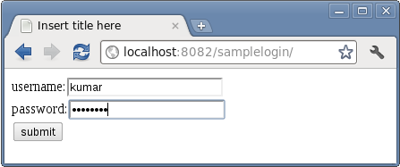

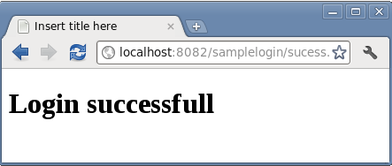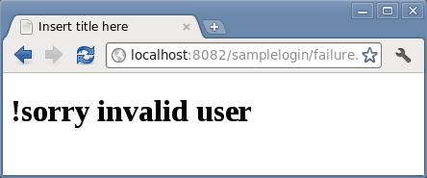

1. Create the following Registartion page using Servlets display the details .

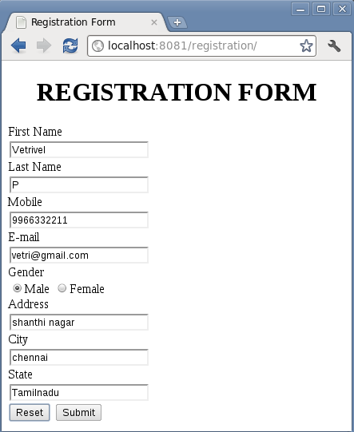

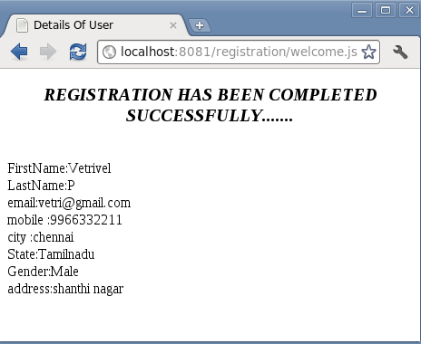

1. Write a Servlet/JSP Program with JDBC to insert Student Record into the database

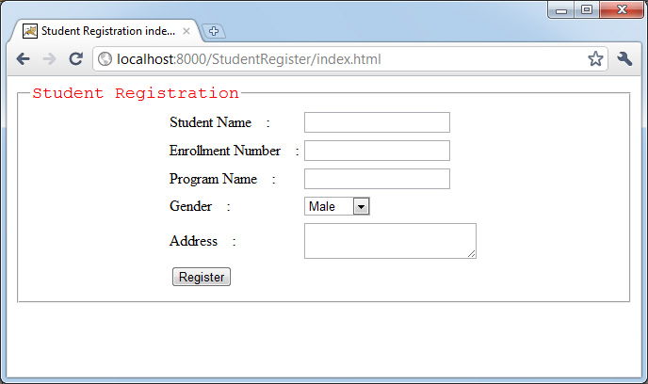

1. Write a Servlet/JSP program to retrieve Display Data from Database in JSP

